**Virtual guide for tourists**

Kavin Kumar  
10th April, 2023

1. Problem Statement:

With the rapid growth in tourism these days there are not sufficient tourism companies or guides to come to its aid. Tourists often find it difficult to decide what to do and where to go when they go someplace where they could not communicate easily. Also, if the destination is remote, you cannot always rely on the locals or local guides to help you out. That might sometimes lead to lose your money if not aware. This report focuses on developing an ML based virtual guide for tourists which will notify its users on what to do and when to do no matter where they go.

2. Market/Customer/Business need assessment:

The products available in the market currently include traditional tour guides and guidebooks. But tour guides can be expensive and guidebooks cannot be expected to have up-to-date information. This is where we introduce our virtual guide which gives out suggestions to users by giving them a perfect schedule also taking into consideration any other external real time factors. A machine learning based approach to suggest users of their plans well ahead can address these challenges by providing real time analysis of data and insights that can help them have a great experience.

Tourists want to make the most of their limited time and budget in a new destination, and they are increasingly relying on technology to help them plan and navigate their trips. They are looking for solutions that are easy to use, customizable, and provide accurate and reliable information about the best things to see and do in a given city. They also value the ability to interact with locals and get recommendations from people who know the city best.

In the highly competitive tourism industry, tour operators and travel companies need to differentiate themselves by offering innovative and personalized solutions that meet the changing needs and preferences of modern travelers. By leveraging the latest in machine learning technology, companies can create virtual guides that provide real-time recommendations and personalized itineraries based on each user's interests and location. This can help tour operators to increase customer satisfaction, loyalty, and revenue while reducing the cost of traditional tour guides. Additionally, such virtual guides can help to attract new customers and retain existing ones by offering a unique and valuable experience.

3. Target specifications and characterization:

3.1 Target User:

The target users for the virtual guide using machine learning technology are tourists visiting new cities who are looking for a more personalized and convenient way to explore their destination. They are tech-savvy, comfortable using mobile apps, and interested in customizing their itinerary based on their interests and preferences.  
  
3.2 Target Market:

The target market for the virtual guide includes tourists visiting major cities around the world, with a focus on popular tourist destinations that attract a high volume of visitors. The market is highly competitive, with many companies offering traditional tour guides, guidebooks, and mobile apps to help tourists explore the city.

3.3 Target Features:

The virtual guide using machine learning technology should have the following features to meet the needs of the target users and market:

* Personalization: Ability to customize the itinerary based on each user's interests and preferences, including recommendations for attractions, restaurants, and experiences.
* Real-time updates: Access to up-to-date information on events, attractions, and weather conditions in the city.
* Interactivity: Ability to interact with locals and get recommendations from people who know the city best, including personalized tips and suggestions based on the user's location.
* Navigation: Access to maps and navigation tools to help users get around the city and find their way to different attractions and experiences.
* Social sharing: Ability to share itinerary and experiences on social media platforms to encourage others to visit the city.

4. External Searches:

<https://www.linkedin.com/pulse/artificial-intelligence-guides-service-travel-tourism-syme-/>

<https://www.hotelmize.com/blog/6-examples-of-how-ai-is-used-in-the-travel-industry/>

<https://www.makeuseof.com/free-travel-planning-ai-chatgpt-apps/>

<https://www.indeed.com/career-advice/career-development/tour-guide-skills>

Dataset:

Any dataset containing information about tourist destinations, such as their locations, historical significance, cultural significance, tourist attractions, etc.

You may also need data about the preferences and behaviors of tourists, such as their preferred mode of transportation, the type of activities they enjoy, and their preferred types of accommodations.

This data could be collected through surveys, social media analysis, or by partnering with travel agencies.

5. Benchmarking alternate products:

There are several existing virtual tourist guide applications that use machine learning and other technologies to provide similar services.

**Google Maps** offers a wide range of features to help tourists navigate their way through a new city. It provides information on places of interest, reviews and ratings, and even offers real-time traffic updates.

**Airbnb, TripAdvisor** are popular platforms for travel planning, offering a range of features such as reviews, ratings, and recommendations for hotels, restaurants, and places of interest.

However, if you compare it with a dedicated ML based guide system, Google maps would not provide you the flexibility you require and would not give personalised recommendations. It may also leave out some unpopular tourist spots but might be of interest to the user.

6. Applicable regulations:

1. Data privacy regulations: The application may need to comply with data privacy regulations.
2. Travel and tourism regulations: The application may need to comply with local, national, and international travel and tourism regulations, such as licensing and permitting requirements, health and safety standards, and accessibility regulations.
3. Review of existing work authority regulations.
4. Advertising and marketing regulations: The Federal Trade Commission's guidelines on endorsements and testimonials, if it includes sponsored content or affiliate marketing.
5. Anti-discrimination regulations: Should not discriminate against any protected groups, such as based on race, gender, or disability, in its recommendations and services.

7. Applicable constraints:

1. Since a very large amount of real time data needs to be processed constantly in order to get up to date accurate information the availability of such reliable data is a challenge and hardware requirements are difficul to be met.
2. Privacy regulations may limit the use of personal data for recommendation algorithms.
3. The success of the application will depend on user adoption and acceptance, which can be influenced by factors such as ease of use, user interface design, and cultural and linguistic differences.

8. Business opportunity:

The virtual tourist guide project presents a unique business opportunity that can generate revenue through a variety of channels. By offering personalized recommendations to travelers based on their interests, preferences, and behavior, the service can attract a large user base seeking a more tailored travel experience.

One potential revenue stream is a **subscription-based model**, where customers are offered a subscription-based service to avail access to the personalized recommendations and other premium features, such as offline access, priority customer support, and advanced analytics.

Another approach is a **commission-based model**, where the virtual tourist guide platform partners with local businesses such as restaurants, museums, and tour operators. By earning a commission on every booking made through the platform, the service can benefit both users and local businesses and build a sustainable business model.

Finally, **data monetization** presents another avenue for revenue generation. By collecting and analyzing data on user behavior, preferences, and travel patterns, the virtual tourist guide platform can sell this data to third-party businesses such as airlines, hotels, and travel agencies.

9. Concept generation:

The problem we are addressing is the lack of personalization in tourist guides. Tourists often rely on generic tour guides or maps, which do not cater to their individual interests or preferences. Therefore, the problem we aim to solve is to create a personalized tourist guide for every individual based on their interests.

The solution to this problem is developing a virtual assistant/guide to help you navigate through such locations and find points of interests for the user. The guide will provide real-time recommendations and suggestions for nearby places based on the tourist's current location, weather conditions, and time of day.

10. Final product prototype:

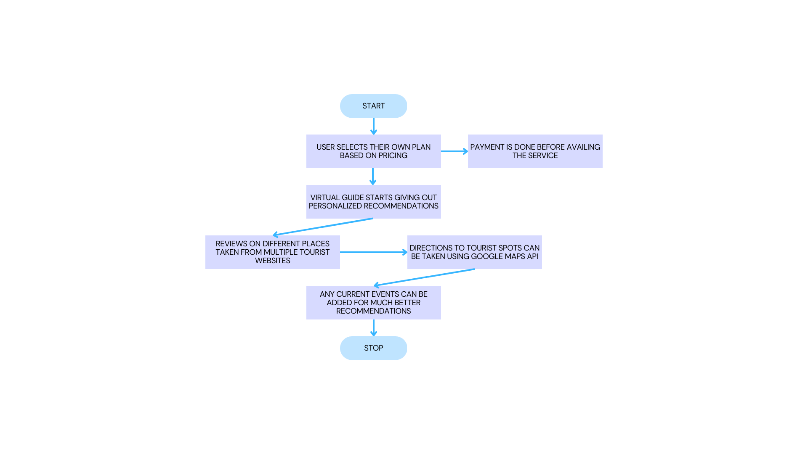

11. Product details:

11.1 Algorithms Required:

To build this virtual guide for tourists using ML, the following algorithms will be required:

1. Natural Language Processing (NLP) algorithms for text processing and speech recognition
2. Computer Vision algorithms for image and video processing
3. Recommender System algorithms for personalized recommendations
4. Data analysis and visualization algorithms for data processing and analysis

11.2 Expense:

The expenses involved in this project will depend on various factors such as the size of the team, the technology used, and the infrastructure required. The cost of the project can be broken down as follows:

1. Salaries and benefits for the team members
2. Infrastructure and software costs
3. Data acquisition and processing costs
4. Marketing and advertising costs
5. Miscellaneous expenses

11.3 Team Required:

To successfully build and launch a virtual guide for tourists, a team with the following skills and expertise will be required:

1. Machine Learning Engineers and Data Scientists
2. Software Developers
3. UX/UI Designers
4. Content Creators and Writers
5. Marketing and Sales Professionals

12. Conclusion:

In conclusion, the virtual guide for tourists using ML has the potential to revolutionize the tourism industry. By utilizing machine learning and computer vision techniques, we can provide a personalized and interactive experience to tourists, helping them discover new places, learn about the history and culture of the location, and navigate their way around the city. Our product offers a unique advantage over existing solutions, such as Google Maps, by providing a comprehensive and personalized experience that caters to the needs of individual tourists.

However, developing this product requires significant effort and resources, including a skilled team of developers, designers, and data scientists. In addition, obtaining the required data, such as images, maps, and tourist information, can be challenging, and ensuring the accuracy and reliability of the algorithms is crucial.

Overall, the virtual guide for tourists using ML has the potential to transform the way tourists experience new locations, and with the right team and resources, it can become a successful business venture in the tourism industry.

13. References:

[1] HARINI B, ASHMITHA K, DEEPAN RAJ K R, JANANI S R (2021) “VIRTUAL TOURIST GUIDE” International Research Journal of Engineering and Technology (IRJET)

[2] Shila Jawale , Sakshi Jadhav , Priyanka Jaybhaye , Nikita Sonavale (2022) “Virtual Tourist Guide” International Journal of Advanced Research in Science, Communication and Technology (IJARSCT)

[3] Dhanraj Solanki , Shiv Patel , Urvesh Patel , Prof .Abhishek Tripathi (2021) “VIRTUAL TOURIST GUIDE” International Journal of Computer Science and Information Technology Research